Neighbourhood Project: Front Yard Cleanup

Student’s Name
Institutional Affiliation
Course
Instructor’s Name
Date

Front yard Cleanup Project
Most of the times people forget the necessity of giving back to the community, to the people who live next to their residence, to the strangers we meet on the streets and even to the most vulnerable people living around them. While the act of volunteering in the society is a significant trend, there is nothing like focusing our energy, time and resources in offering a helping hand to our neighbours (Hoxmeier & Lenk, 2020). There is a strong bond created by having various shared experiences with the neighbourhood and the community at large. That’s why I took the initiative to help out my front neighbour Larissa in Houston, TX. 77053 in cleaning her front Yard. The focus of this project was the wholeheartedly to help my aged neighbour, who had retired and mostly stayed at home. She had no one else to help her in most of the home chores because her husband was employed and worked from Mondays to Saturdays.
On August 7, 2020, I arrived very early at Mrs Larissa’s home and reviewed to her the whole plan for the day. I had come up with a front yard clean up a checklist to make sure I had an idea that would easily be handled. In addition to that, I had also gathered all the required working tools that are from the mower, hose pipes and rakes, among others. Working on the lawn was the first step. The lawn grass was 3 inches tall and therefore was ready for mowing. This gave it ample time to sprout again after the winter. Pet messes and traffic had extremely ruined the grass, so I decided to put soil on it together with fertilizer and grass seed so that it would sprout again. In addition to that, I also removed the debris, twigs and tree branches that were cluttering the lawn (Garrity, 2020).
The second step was to clip the dead shrubs, trees and perennials around the Front Yard. This was necessary to make sure they had a solid foundation for growth. In addition to that, these trees and shrubs could quickly receive sunlight during summer and also prevent them from accidentally breaking off. I then embarked on the garden beds. I started by clearing them of unruly weeds, dead foliage and fallen leaves before the full swing of the spring season came in. In the next phase, I dug up the perennials and used them to fill the sparse points in the garden. I then moved to the pathways and patio to make them ready to entertain. Some outdoor furniture is also needed some cleaning, and therefore we used a mixture of warm water and liquid soap to do so. Using a hosepipe, I sprayed on theses wooden and metallic outdoor furniture then used a scrub brush to remove the dark spots. Lastly, I cleaned up the leaves shed from the oak tree on the front Yard using the wooden broom. I first collected the layers and the massive piles of the leaves, which had resulted in mould and decay. This was followed finally by removing the small debris on the paths which were making them quite unattractive.
By the end of this project, the Front Yard of Mrs Larissa was more inviting. The couple could not hide their joy and enthusiasm about my visit to their home. It was evident that they gladly cherished the time I spent on their front Yard. On my side, I was also able to make a fantastic connection with them, and I am still keeping in touch to know how the Yard is reviving itself.
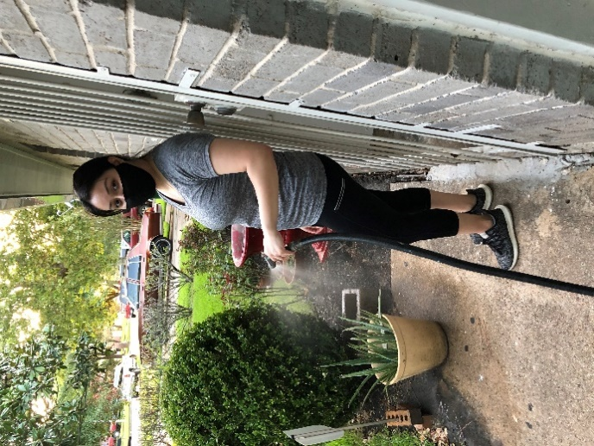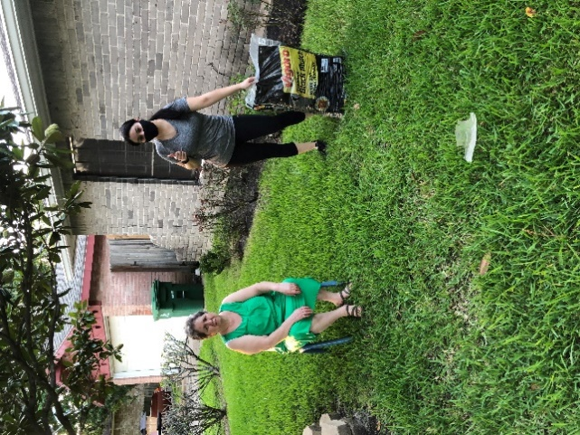

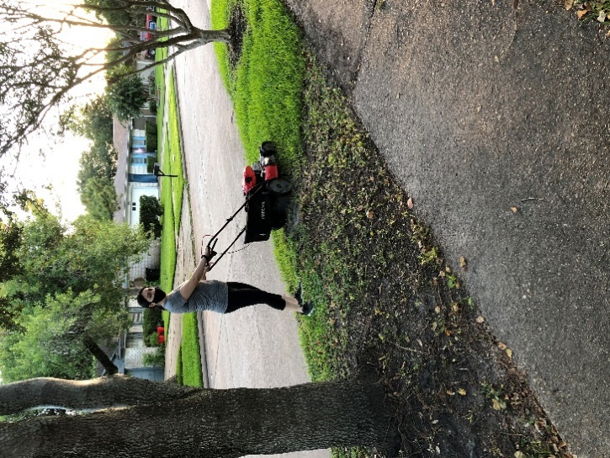

References
Garrity, A. (2020). Follow This Spring Yard Clean Up Checklist to Make Your Patio and Lawn Summer-Ready. Retrieved August 12 2020, from https://www.goodhousekeeping.com/home/gardening/advice/a19217/spring-clean-your-yard/
Hoxmeier, J., & Lenk, M. M. (2020). Service-learning in information systems courses: Community projects that make a difference. Journal of Information Systems Education, 14(1), 10.

